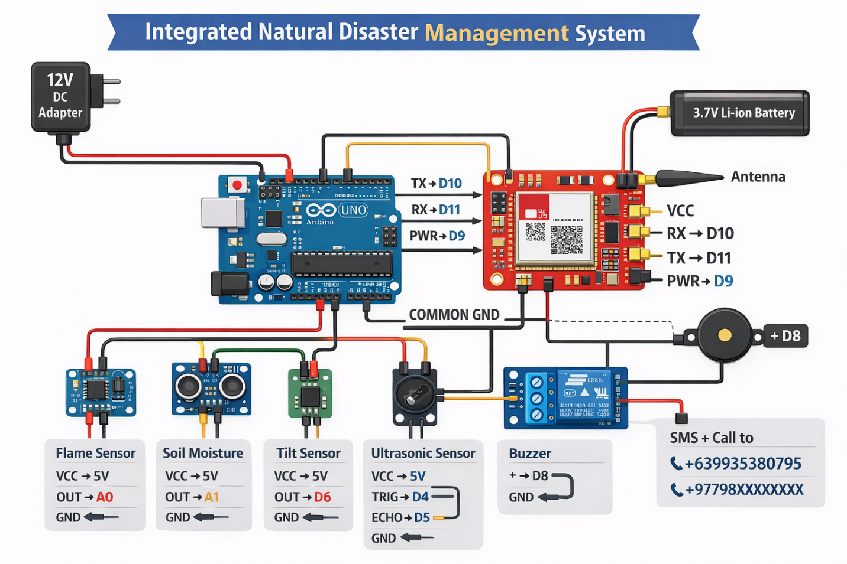

1️⃣ Power Supply Table
Component | Power Source | Voltage | Notes / Safety
Arduino UNO R3 | 12V DC Adapter | 12V | Connect to VIN or DC jack. Regulated to 5V for sensors.
SIM800L GSM Module | 3.7V Li-ion battery | 3.7V–4.2V | Do NOT power from Arduino 5V. Common GND with Arduino required.

2️⃣ Sensor Pin Table
Sensor | Arduino Pin | Type | Power | Notes
Flame Sensor | A0 | Analog | 5V | Detects fire. Adjust threshold in code (500 used).
Soil Moisture Sensor | A1 | Analog | 5V | Detects landslide possibility by dry soil.
Tilt Sensor (Earthquake) | D6 | Digital | 5V | Detects vibration / tilting of surface. HIGH = detected.
Ultrasonic Sensor (HC-SR04) | TRIG → D4, ECHO → D5 | Digital | 5V | Measures distance to detect landslide risk (distance < 10cm).

3️⃣ Output Devices Table
Device | Arduino Pin | Power | Notes
Buzzer | D8 | 5V | Beeps when any disaster is detected. Active type.

4️⃣ SIM800L GSM Module Table
SIM800L Pin | Arduino Pin / Connection | Notes
TX | D10 → Arduino RX | Send data from SIM800L to Arduino
RX | D11 → Arduino TX | Receive data from Arduino to SIM800L
PWR KEY | D9 | Control power on/off via Arduino
VCC | 3.7V battery + | Use proper battery. 2A peak current required.
GND | Common GND | Connect both Arduino GND and Battery –
Antenna | Attached | Required for network connectivity

5️⃣ Disaster Trigger Logic Table
Disaster Type | Trigger Condition | Output Action
Fire | Flame sensor > 500 | Buzzer ON + SMS + Call
Landslide | Soil < 300 AND Distance < 10cm | Buzzer ON + SMS + Call
Earthquake | Tilt sensor HIGH | Buzzer ON + SMS + Call

6️⃣ SMS + Call Numbers Table
Type | Phone Number
SMS + Call | +639935380795
SMS + Call | +97798XXXXXXXX

7️⃣ Notes for Safe Operation
Item | Recommendation
SIM800L Power | Must use 3.7–4.2V Li-ion battery. Do not use Arduino 5V.
GND | All modules must share common GND (Arduino + Battery + Sensors + SIM800L).
Antenna | Attach to SIM800L for stable SMS and call.
Testing | Test each sensor individually before full system test.
Code Thresholds | Flame = 500, Soil = 300, Distance = 10cm (adjust after testing).

Code
// ================= PIN DEFINITIONS =================
#define FLAME A0 // Flame sensor analog input
#define SOIL A1 // Soil moisture analog input
#define TRIG 4 // Ultrasonic trigger
#define ECHO 5 // Ultrasonic echo
#define TILT 6 // Tilt sensor digital input
#define BUZZER 8 // Buzzer output

#define SIM_TX 10 // SIM800L TX
#define SIM_RX 11 // SIM800L RX
#define SIM_PWR 9 // SIM800L PWR KEY

#include <SoftwareSerial.h>
SoftwareSerial sim800(SIM_TX, SIM_RX);

// ================= SETUP =================
void setup() {
pinMode(FLAME, INPUT);
pinMode(SOIL, INPUT);
pinMode(TILT, INPUT);
pinMode(TRIG, OUTPUT);
pinMode(ECHO, INPUT);
pinMode(BUZZER, OUTPUT);
pinMode(SIM_PWR, OUTPUT);

Serial.begin(9600);
sim800.begin(9600);

// Turn on SIM800L
digitalWrite(SIM_PWR, HIGH);
delay(3000);

Serial.println("SYSTEM READY");
}

// ================= MAIN LOOP =================
void loop() {
int flameVal = analogRead(FLAME);
int soilVal = analogRead(SOIL);
int tiltVal = digitalRead(TILT);
long distance = measureDistance();

bool disasterDetected = false;
String alertMessage = "";

// Check Flame
if (flameVal > 500) {
disasterDetected = true;
alertMessage = "🔥 FIRE ALERT: Fire detected!";
}
// Check Landslide
else if (soilVal < 300 && distance < 10) {
disasterDetected = true;
alertMessage = "🌧 LANDSLIDE WARNING: Soil loose!";
}
// Check Earthquake
else if (tiltVal == HIGH) {
disasterDetected = true;
alertMessage = "🌍 EARTHQUAKE MOTION DETECTED!";
}

if (disasterDetected) {
// Buzzer ON
digitalWrite(BUZZER, HIGH);
Serial.println(alertMessage);

// Send SMS + Call to two numbers
sendSMS(alertMessage);
makeCall();

// Keep buzzer ON for 12 seconds
delay(12000);
digitalWrite(BUZZER, LOW);
} else {
digitalWrite(BUZZER, LOW);
}

delay(1000); // small delay between readings
}

// ================= ULTRASONIC DISTANCE FUNCTION =================
long measureDistance() {
digitalWrite(TRIG, LOW);
delayMicroseconds(2);
digitalWrite(TRIG, HIGH);
delayMicroseconds(10);
digitalWrite(TRIG, LOW);
long duration = pulseIn(ECHO, HIGH);
return duration * 0.034 / 2; // Distance in cm
}

// ================= SEND SMS TO TWO NUMBERS =================
void sendSMS(String msg) {
sendText("+639935380795", msg); // Replace with your first number
sendText("+97798XXXXXXXX", msg); // Replace with your second number
}

void sendText(String number, String message) {
sim800.println("AT"); // Test module
delay(500);
sim800.println("AT+CMGF=1"); // Set SMS text mode
delay(800);
sim800.println("AT+CMGS=\"" + number + "\""); // Recipient
delay(800);
sim800.println(message); // Message content
delay(500);
sim800.write(26); // CTRL+Z to send
delay(4000);
Serial.println("📩 SMS sent to " + number);
}

// ================= CALL TWO NUMBERS =================
void makeCall() {
callNumber("+639935380795"); // First number
callNumber("+97798XXXXXXXX"); // Second number
}

void callNumber(String number) {
sim800.println("ATD" + number + ";"); // Dial number
Serial.println("📞 Calling " + number);
delay(15000); // Ring 15 sec
sim800.println("ATH"); // Hang up
delay(1500);
}

